Oracle Database Administration Services
Scheduling in Windows, UNIX and Oracle



This document contains proprietary information of Wipro Infotech – MIT. No part of this publication may be reproduced, stored in a retrieval system or transmitted in any form or by any means, whether electronic, mechanical, photocopying, recording or otherwise, without the prior written permission of Wipro Infotech – MIT. The information contained herein is confidential to Wipro Infotech – MIT and <Customer Name> and shall not be distributed to any persons other than those involved in the assessment and delivery of services. Wipro Infotech – MIT reserves the right to revise and update this document as and when required. Wipro Infotech – MIT reserves the right to withdraw the document excluding customer specific information at the time of termination of services.

All product names referenced herein are trademarks of their respective companies.
Document Management Information
Document Title : Scheduling job in Windows, UNIX and Oracle
Document Status : Draft / Review / Approval / Final
Document Publication History
(All revisions made to this document must be listed in chronological order)
Version | Date | Author(s) | Remarks
1.0 | 01-11-2008 | Buvanesh Mohana Murugan | Initial Draft Document
 | 24-07-2014 | Vineet Walia | Review and Update
 | 18-07-2016 | Hemanti Thackeray | Review and update
Document Review and Approval History
(All revisions must be approved. Review and Approval can be done by an internal source or by the customer)
Version | Date | Reviewer & Approver | Remarks | Signature
1.0 | 20-01-08 | Premchand Ryali | Review
1.0 | 18-07-2016 | Jagdish Chauhan | Approval
Document Distribution List
Sl. No. | Name and Company | Purpose
1
2

TABLE OF CONTENT
1. Purpose 1
2. Scope 1
3. Technical Methodology 1
3.3.1 INIT.ORA Parameters 14
3.3.2 Managing Job Queues 14
3.3.3 Viewing Job Information in the Data Dictionary 24
4. Best Practices 25
5. Reference 26
5.1 For Scheduling In Windows References 29
5.2 For Scheduling In Unix References 29
5.3 For Scheduling In Oracle References 29

Purpose
This document is prepared for the management and troubleshooting of Oracle Database Administration Services at <Customer Name>.

Scope
This document is prepared for <Customer Name> Wipro sustenance team and provides the concepts, management and troubleshooting aspects of Scheduling in Windows, UNIX and Oracle for the administration at <Customer Name>.

Technical Methodology
Scheduling allows us to schedule different tasks and jobs to run at specified time for specific interval of time.
Scheduling can be done in following ways:
- Scheduling Tasks in Windows.
- Scheduling jobs using Cron in UNIX.
- Scheduling jobs using DBMS_JOBS in Oracle.

3.1 Scheduling Tasks in Windows

Scheduling a task allows us to schedule any script, program or document to run at a specified time.
In Windows, we can schedule a task using “Scheduled Tasks”.

3.1.1 Scheduled Tasks
Scheduled Tasks provide a way to schedule activities to run on a computer at specific days and at specific times. Scheduled Tasks starts each time we start Windows. It runs in the background.
With Scheduled Tasks, we can also:
- Schedule a task to run daily, weekly, monthly, or at certain times (such as system startup).
- Change the schedule for a task.
- Stop a scheduled task.
- Customize how a task will run at a scheduled time.
3.1.2 Managing Tasks using Scheduled Tasks

Step 1: Create a batch file

Initially, create a batch file.

To create a batch file, follow the following steps:

- Open notepad
Start > Programs > Accessories > Notepad.
B. Write the script that is required to be executed.
- Save it with .bat extension
- File > Exit.

Step 2: Schedule the Task using Scheduled Tasks

Open the Scheduled Tasks.

To open the Scheduled Tasks, follow the following path:
Start > Programs > Accessories > System Tools > Scheduled Tasks

Now the following window will be displayed.

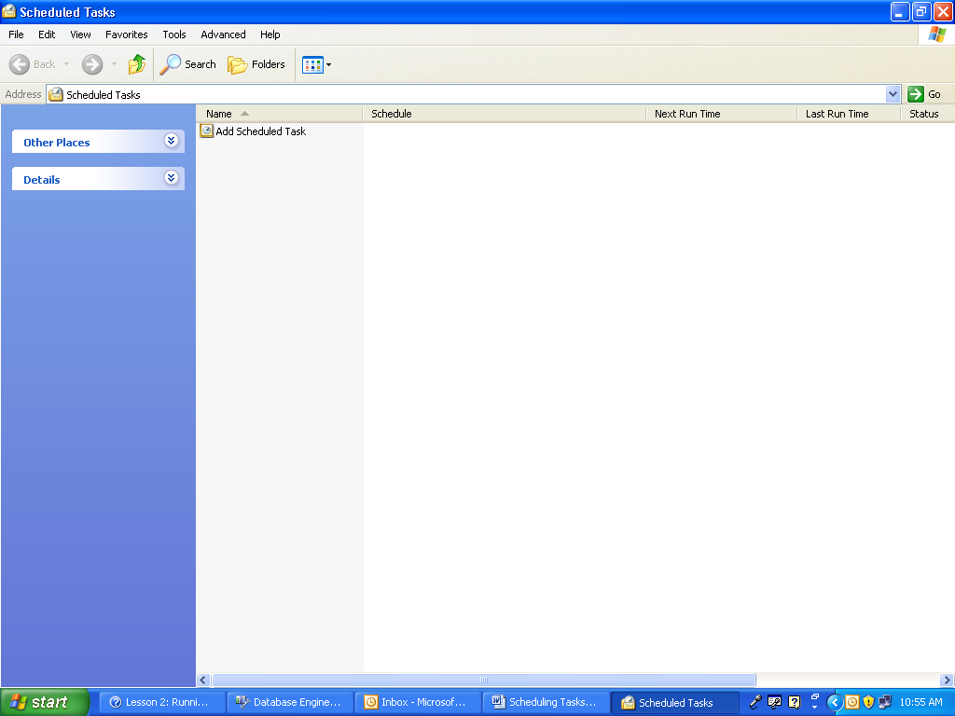

Double click on the “Add Scheduled Tasks”.

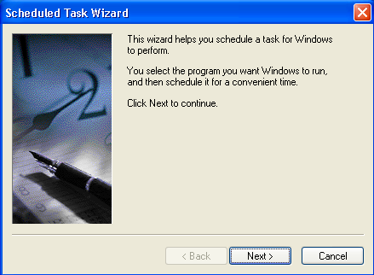

Click Next.

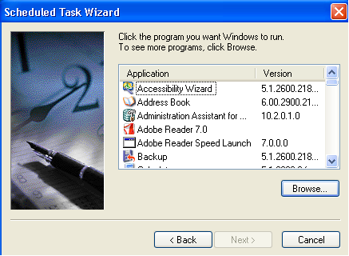

Click the Browse button to select the batch file script which has to be scheduled. Then click Next.
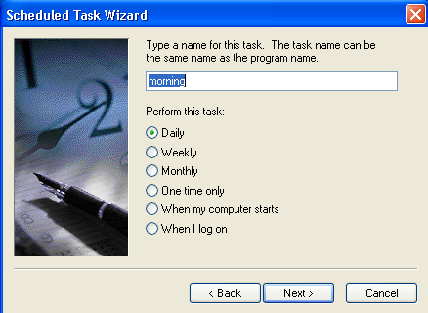

Now type a name for the task. And select the periodicity after which the task will be performed.

Click the Next button.

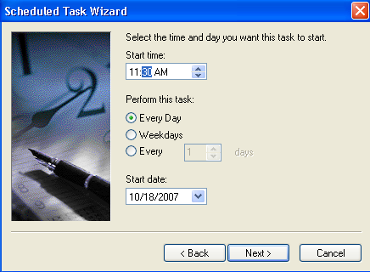

Select the Start time and day on which the task has to be started. Click the Next button.

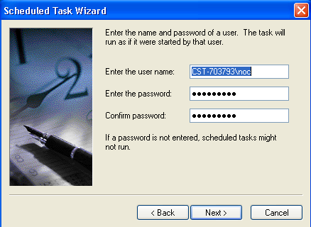

Enter the username and password. And click the next button.

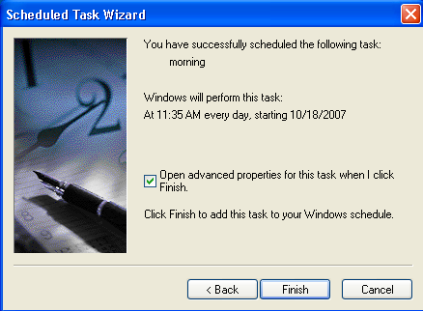

Check the “Open advanced properties for this task when I click Finish.” checkbox to open the advanced options when the task is created.

Click the Finish button.

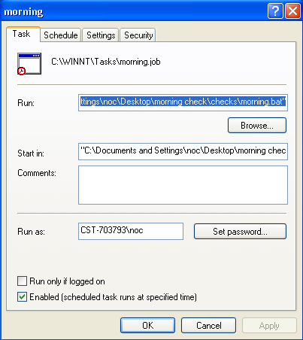

On clicking Finish button the above window will be opened.

Click OK to set the Password.

Go to “Schedule” tab to schedule the task to run repeatedly.
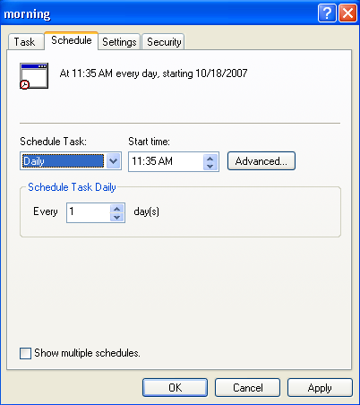

Click the Advanced button. The following window will be opened.

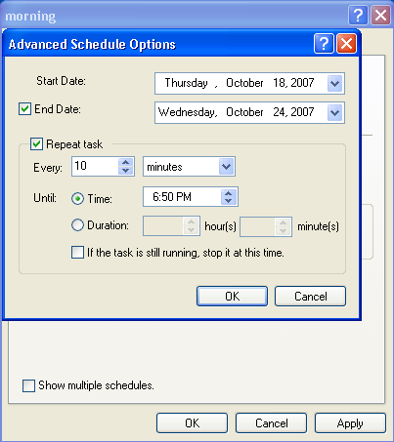

Check the “Repeat task” checkbox, if the task has to be run repeatedly.

Specify the duration after which the task has to be executed. You can also specify the ending date and time. Ending time can be specified in the “End Date”. And ending time can be specified in the “Until Time” or “Until Duration” section.

Click the OK button.

Click the Apply and OK button, to apply the changes.

Now a new task morning will be displayed in the window as follows:

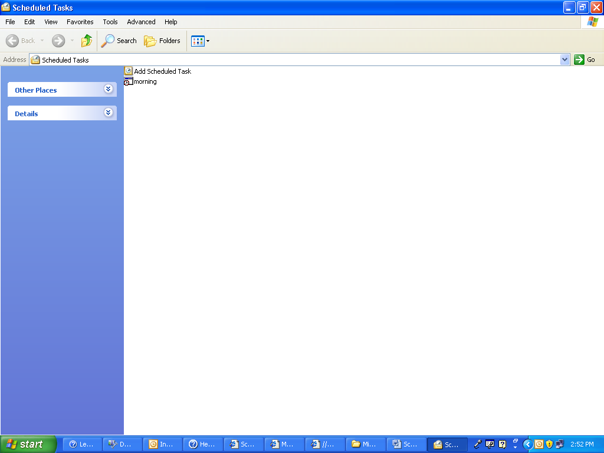

Manually running the task:

To manually run the task, follow the following steps:

Right Click on task> Run

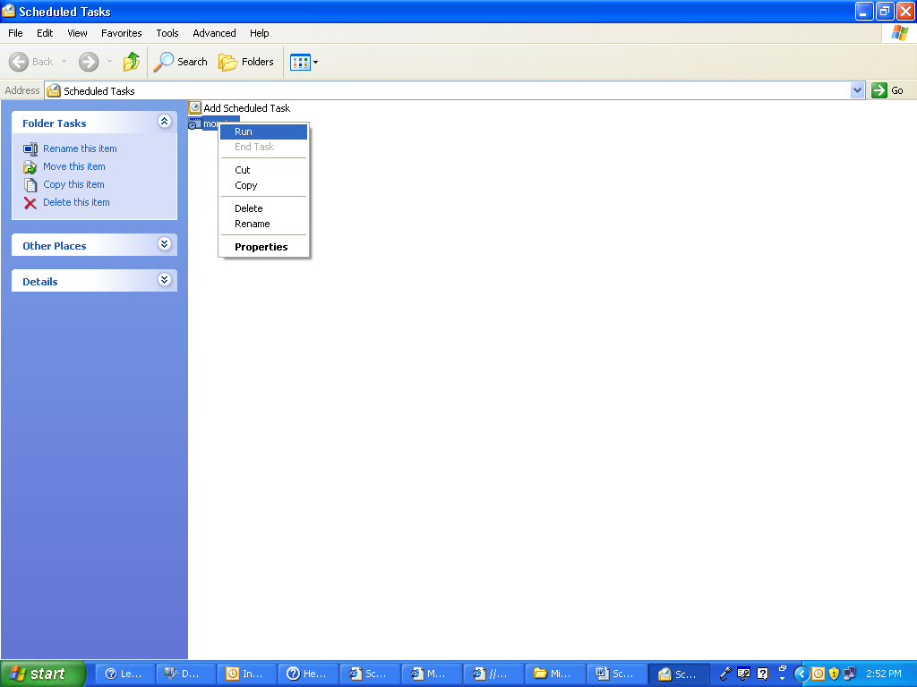

3.1.3 Note:

3.1.3.1 Error:

If the following error message is displayed when the Finish button is clicked:

“The new task is created, but may not run because the account information can not be set.
The specific error is:
0x80070005: Access is denied.
Try using the Task page browse button to locate the application.”

Then

Right Click on task > Properties

In the Task tab specify the correct username and password. Username can be specified in the “Run as:” textbox. And for setting password click the “Set password…” button.

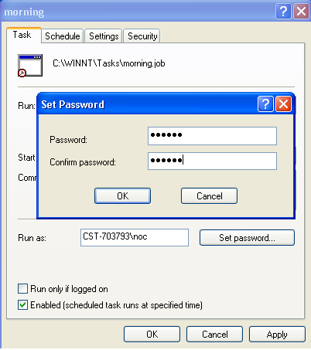

3.1.3.2 Sample Batch File

@ECHO OFF
TITLE Morning Checklist
sqlplus"<USERNAME>/<PASSWORD>@connect_descriptor "@C: \script.sql
exit

USERNAME: It is the Username that is required to connect to the database.

PASSWORD: It is the password of the associated user.

connect_descriptor: It is the connect descriptor name.

script.sql : This file contains the SQL statements that are required to be executed.

3.2 Scheduling jobs using Cron

Cron is a UNIX/ solaris utility that allows tasks to be automatically run in the background at regular intervals by the cron daemon. These tasks are often termed as cron jobs in UNIX/ Solaris.
The commands to be executed are specified in a standardized tabular format. These are stored in files referred to as crontab files. Crontab (CRON TABle) is a file which contains the schedule of cron entries to be run at specified times.

The Commands that are executed automatically by being placed in a crontab file (scripts) are referred to as Cron Jobs.

3.2.1 Managing Crons:

Managing of Crons include various aspects. These are as follows:

- Creation and edition of Cron,
- Listing jobs using Cron.
- Disabling Cron.

3.2.1.1 Creation of cron

The cron can be created using the following method:

- Create a script.
- Create the crontab file.

3.2.1.1.1 Create a script

To create a script follows the following steps:

1. Connect to AIX using PUTTY.

2. Specify the correct username and password

3. In the shell prompt, give the following command:

vi <filename>.sh

Write the code for the script and save and quit using <:wq> command.

3.2.1.1.2 Creating the Crontab file

To create and edit crontab, use the following syntax:

crontab –e

This command will invoke the editing session so that the crons listed can be edited as per needs.
After necessary modifications we need to save it using <!wq >command.

Crontab syntax

A crontab file has five fields for specifying day, date and time followed by the command to be run at that interval.

* * * * * command to be executed
- - - - -
| | | | |
| | | | +----- day of week (0 - 6) (Sunday=0)
| | | +------- month (1 - 12)
| | +--------- day of month (1 - 31)
| +----------- hour (0 - 23)
+------------- min (0 - 59)

Example:

0 6 * * * /home/db/cron/example.sh

As per this example, the cron example.sh is scheduled at 6’0 clock every day. The script example.sh should be in the path ‘home/db/cron’.

3.2.1.2 Listing the Crontab file

To list the crontab, type the following command:

crontab –l

This crontab command lists the cron jobs, directory and their schedules.

3.2.1.3 Cron Disabling:

For disabling the crons, put a ‘#’ symbol in front of the cron job which needs to be disabled

# 0 6 * * * /home/db/cron/example.sh – To disable

0 6 * * * /home/db/cron/example.sh – To enable.

3.3 Scheduling Jobs Using DBMS_JOBS in Oracle
Oracle database offers a job queue for scheduling certain operations to happen routinely in a database. The functionality is similar to UNIX cron jobs with the primary difference being if your database is not running, the job will not attempt to run. Oracle will start a coordinator job queue (CJQ0) process to handle scheduled jobs. The CJQ0 process will keep track of the schedule. The CJQ0 process start helper processes (J000 – J999) to execute the scheduled jobs.

3.3.1 INIT.ORA Parameters
These three INIT.ORA parameters are required to control the job queue:
- job_queue_processes
- job_queue_interval
3.3.1.1 JOB_QUEUE_PROCESSES
The job queue (or SNP) background processes are started when the Oracle instance is started. There are as many SNP processes started as specified in the INIT.ORA parameter JOB_QUEUE_PROCESSES. The range of valid values is from 0 to 36, so there can be a maximum of 36 SNP processes per Oracle instance.

3.3.1.2 JOB_QUEUE_INTERVAL

The job queue processes "wake up" periodically and check the job queue catalog to see if any jobs are due to execute. The INIT.ORA parameter JOB_QUEUE_INTERVAL controls how long the SNP processes "sleep" (in seconds) between job queue catalog checks.
For most purposes, the default setting of 60 seconds is adequate.

3.3.2 Managing Job Queues
Various aspects of managing job queues through the DBMS_JOB package are as follows:
- Submitting a Job to the Job Queue
- Removing a Job from the Job Queue
- Altering a Job
- Broken Jobs
- Forcing a Job to Execute
The DBMS_JOB package is used to schedule and manage jobs in the job queue. To achieve this we have to use procedures supplied under the DBMS_JOB package.

3.3.2.1 Submitting a Job to the Job Queue using DBMS_JOB.SUBMIT
To submit a job to the job queue, use the following syntax:
DBMS_JOB.SUBMIT (JOB OUT BINARY_INTEGER,
WHAT IN VARCHAR2,
NEXT_DATE IN DATE DEFAULTSYSDATE,
INTERVAL IN VARCHAR2 DEFAULT 'NULL',
NO_PARSE IN BOOLEAN DEFAULT FALSE,
INSTANCE IN BINARY_INTEGER DEFAULT ANY_INSTANCE,
FORCE IN BOOLEAN DEFAULT FALSE);

Parameter Description
job - An output parameter. This is the identifier assigned to the job you are creating. You must use this job number whenever you want to alter or remove the job.
what - The PL/SQL code you want to execute.
next_date - The next date when the job will be run. The default value is SYSDATE.
interval - The date function that calculates the next time to execute the job. The default value is NULL. INTERVAL must evaluate to a future point in time or NULL.
no_parse - If FALSE (default), then Oracle parses the associated procedure with the job. If TRUE, then the procedure is parsed only the first time the job is run.
instance - Specifies which instance can execute the job
force - If FALSE, then the instance must already be running or else it will return an error.

Example:

SQL> variable jobnumber number
SQL> begin
2 dbms_job.submit(job=>:jobnumber,
3 what=>'dbms_stats.gather_database_stats options=>''gather'');',
4 next_date=>SYSDATE,
5 interval=>'SYSDATE+1/24');
6 end;
7 /
PL/SQL procedure successfully completed.
SQL> print jobnumber
JOBNUMBER
----------
24

3.3.2.2 Removing a Job from the Job Queue using DBMS_JOB.REMOVE
Syntax:

DBMS_JOB.REMOVE (job IN BINARY_INTEGER );
Parameter Description:
job - The number of the job already held in the job queue.
Example:
SQL> select job from dba_jobs;
JOB
----------
1
22
23
24
4 rows selected.

SQL> begin
2 dbms_job.remove(24);
3 end;
4 /

PL/SQL procedure successfully completed.

SQL> select job from dba_jobs;
JOB
----------
1
22
23
3 rows selected.

3.3.2.3 Altering a job
3.3.2.3.1 Altering a Job using DBMS_JOB.CHANGE
DBMS_JOB.CHANGE alters a specified job that has already been submitted to the job queue. The job description, the time at which the job will be run, the interval between executions of the job, and the instance and force of a job can all be altered.
Syntax:
DBMS_JOB.CHANGE (
job IN BINARY_INTEGER,
what IN VARCHAR2,
next_date IN DATE,
interval IN VARCHAR2,
instance IN BINARY_INTEGER DEFAULT NULL,
force IN BOOLEAN DEFAULT FALSE);

Parameter Description:

job - Number of the job being run.
what - PL/SQL procedure to run.
next_date - Date of the next refresh.
interval - Date function evaluated immediately before the job starts running.
instance - When a job is submitted, specifies which instance can run the job. This defaults to NULL, which indicates that instance affinity is not changed.
force - If this is FALSE, then the specified instance must be running. Otherwise, the routine raises an exception. If this is TRUE, then any positive integer is acceptable as the job instance.

Example:

SQL> begin
2 dbms_job.change(job=>23,what=>NULL,next_date=>NULL,
interval=>'SYSDATE+7');
3 end;
4 /

PL/SQL procedure successfully completed.

3.3.2.3.2 Altering definition of a Job using DBMS_JOB.WHAT
The definition of a job can be altered by calling the DBMS_JOB.WHAT procedure.
DBMS_JOB.CHANGE (
job IN BINARY_INTEGER,
what IN VARCHAR2);
Parameter Description
job - Number of the job being run.
what - PL/SQL procedure to run.

Example:
SQL> select job,what from dba_jobs;

JOB WHAT
---------- -------------------------
1 EMD_MAINTENANCE.EXECUTE_E
M_DBMS_JOB_PROCS();

22 dbms_ddl.analyze_object('
TABLE','LOAD1','TENK','ES
TIMATE',null,estimate_per
cent=>50);

23 dbms_stats.gather_databas
e_stats(options=>'gather'
);

3 rows selected.

SQL> execute dbms_job.what(22,'dbms_stats.gather_database_stats(options=>''gather'');');

PL/SQL procedure successfully completed.

SQL> select job,what from dba_jobs;

JOB WHAT
---------- -------------------------
1 EMD_MAINTENANCE.EXECUTE_E
M_DBMS_JOB_PROCS();

22 dbms_stats.gather_databas
e_stats(options=>'gather'
);

23 dbms_stats.gather_databas
e_stats(options=>'gather'
);

3 rows selected.

3.3.2.3.3 Altering time of execution of Job using DBMS_JOB.NEXT_DATE
Alters the next execution time for a specified job.
DBMS_JOB.NEXT_DATE (JOB IN BINARY_INTEGER,
NEXT_DATE IN DATE);

Parameter Description:

job - Number of the job being run.
next_date - Date of next refresh.

Example:
SQL> select job,next_date from dba_jobs;

JOB NEXT_DATE
---------- -------------------
1 2007:10:23:16:27:39
22 2007:10:23:17:02:30
23 2007:10:22:15:23:10
3 rows selected.

SQL> execute DBMS_JOB.NEXT_DATE(22,SYSDATE+3);

PL/SQL procedure successfully completed.

SQL> select job,next_date from dba_jobs;

JOB NEXT_DATE
---------- -------------------
1 2007:10:23:16:29:45
22 2007:10:26:16:28:56
23 2007:10:22:15:23:10

3 rows selected.

3.3.2.3.4 Altering a Job using DBMS_JOB.INTERVAL
Alters the interval between executions for a specified job.
DBMS_JOB.INTERVAL (job IN BINARY_INTEGER,
interval IN VARCHAR2);

Parameter Description:

job - Number of the job being run.
interval - Character value that specifies the interval as a date expression.

Example:
SQL> select job,interval from dba_jobs;

JOB INTERVAL
---------- --------------------
1 sysdate + 1 / (24 *
60)

22 trunc(sysdate+1)
23 SYSDATE+1/24

3 rows selected.

SQL> execute dbms_job.interval(22,'sysdate+1/24');

PL/SQL procedure successfully completed.

SQL> select job,interval from dba_jobs;

JOB INTERVAL
---------- --------------------
1 sysdate + 1 / (24 *
60)

22 sysdate+1/24
23 SYSDATE+1/24

3 rows selected.

3.3.2.4 Broken Jobs
Sets or resets the job broken flag. If a job is marked as broken, Oracle does not attempt to execute it.
Syntax:

DBMS_JOB.BROKEN (job in binary_integer,
broken in boolean,
next_date in date default sysdate);

Parameter Description:

job - Job being run.
broken - TRUE or FALSE.
next_date - Date of next refresh.

Example:

SQL> select job,log_user,broken,priv_user from dba_jobs;

JOB LOG_USER B PRIV_USER
---------- ------------------------------ - ------------------------------
1 SYSMAN N SYSMAN
22 SYS N SYS
23 SYS N SYS

3 rows selected.

SQL> begin
2 dbms_job.broken(job=>22,broken=>TRUE);
3 end;
4 /

PL/SQL procedure successfully completed.

SQL> select job,log_user,broken,priv_user from dba_jobs;

JOB LOG_USER B PRIV_USER
---------- ------------------------------ - ------------------------------
1 SYSMAN N SYSMAN
22 SYS Y SYS
23 SYS N SYS

3 rows selected.

Note:
A job is labeled as either broken or not broken. When you submit a job, it is considered not broken. There are two ways a job can break:
- Oracle has failed to successfully execute the job after 16 attempts or
- You have marked the job as broken using the procedure DBMS_JOB.BROKEN
Once a job has been marked as broken, Oracle will not attempt to execute the job until you either mark the job as not broken or force the job to be executed by calling the procedure DBMS_JOB.RUN.
- Forcing a Job to Execute

3.3.2.5 Forcing a Job to Execute DBMS_JOB.RUN
DBMS_JOB.RUN forces a specified job to run.
Syntax:
DBMS_JOB.RUN (job IN BINARY_INTEGER,
force IN BOOLEAN DEFAULT FALSE);

Parameter Description

job - Number of the job being run
force - If FALSE, the specified instance must be already running or else will return an error
Example:
SQL> begin
2 dbms_job.run(job=>22);
3 end;
4 /

PL/SQL procedure successfully completed.

3.3.3 Viewing Job Information in the Data Dictionary
Information about jobs in the job queue is available through several data dictionary views. These are as follows:
DBA_JOBS: DBA_JOBS lists information on all the jobs in the database.
ALL_JOBS: ALL_JOBS has the same information as DBA_JOBS but only on jobs which are accessible to the current user.
USER_JOBS: USER_JOBS again has the same job information, but will only list jobs owned by the current user.
DBA_JOBS_RUNNING: DBA_JOBS_RUNNING contains information on all jobs currently running in the database. This view can be joined with the other views for detailed information on running jobs.

? How to determine what are jobs in the database and time of execution
SQL> select job,last_date,this_date,next_date,total_time,failures from dba_jobs;

JOB LAST_DATE THIS_DATE NEXT_DATE
---------- ------------------- ------------------- -------------------
TOTAL_TIME FAILURES
---------- ----------
1 2007:10:23:15:45:09 2007:10:23:15:46:09
5246 0

22 2007:10:22:14:23:10 2007:10:22:15:23:14 2007:10:22:15:23:10
89764 0

23 2007:10:22:16:25:48 2007:10:23:16:25:48
0 0

3 rows selected.
Description

job: Unique identifier of the job.
last_date: Last successful execution date.
this_date: Date current execution began, or NULL if not executing
next_date: Date of next scheduled execution
total_time: Total elapsed time in seconds for all executions of this job
failures: Number of consecutive unsuccessful executions

4. Best Practices
4.1 Best practices for scheduling jobs in Windows
- To perform scheduling using scheduled tasks, you must be a member of the Administrators, Backup Operators, or Server Operators, or have been delegated the appropriate authority, on the local computer. As a security best practice, consider using Run as to perform this procedure.
- Confirm that the system date and time on your computer are accurate, as Task Scheduler relies on this information to run scheduled tasks.

4.2 Best practices for scheduling jobs in UNIX using cron
- Ensure not to have cronjobs in production hours.
4.3 Best practices for scheduling jobs in Oracle using DBMS_JOB
- On some platforms and versions of Oracle, a COMMIT is required for the job to be picked up by the job queue for execution. If submitted jobs do not seem to be executing at all, this may be the cause. The workaround for this problem is to always COMMIT immediately after calling SUBMIT
- The CHANGE, NEXT_DATE, WHAT, REMOVE, BROKEN, RUN and INTERVAL procedure can be executed only for jobs owned by the username to which the session is connected. These jobs are visible in the dictionary view USER_JOBS.

5. Reference
5.1 For scheduling in windows references are:
- http://technet2.microsoft.com/windowsserver/en/library/ca7f5ceb-a55a-45e2-b8ef-c54a870acf431033.mspx?mfr=true
- http://support.microsoft.com/kb/308569
- http://support.microsoft.com/kb/308671/
5.2 For scheduling in UNIX using cron references are:
- www.mkssoftware.com/docs/man1/crontab.1.asp
- http://www.adminschoice.com/docs/crontab.htm
5.3 For scheduling in ORACLE using DBMS_JOBS references are:
- http://www.unix.org.ua/orelly/oracle/bipack/ch13_01.htm
- http://www.lifeaftercoffee.com/2006/01/23/scheduling-jobs-using-oracles-job-queue/
- http://oraclegeek.net/joomla/content/view/12/30/1/2/
- http://www.unix.org.ua/orelly/oracle/bipack/ch13_03.htm

